## Project report Template

1. NTRODUCTION

1.1 Overview

People who work frequently travel through flight will have better knowledge on best discount and right time to buy the ticket. For the business purpose many airline companies change prices according to these a sons or time duration. They will increase the price when people travel more. Estimating the highest prices of the airlines data for the route is collected with features such as Duration, Source, Destination , Arrival and Departure. Features are taken from chosen dataset and in the price wherein the airline price ticket costs vary overtime. we have implemented flight price prediction for users by using KNN, decision tree and random forest algorithms. Random Forest shows the best accuracy of 80% for predicting the flight price. Also , we have done correlation tests and metrics for the statistical analysis.

1.2 Purpose

 A booking is an arrangement **to reserve a certain ticket, accommodation or a place in advance**. Prices can be frozen by booking to pay a more affordable price for travel scheduled in the future.

2 Problem Definition & design Thinking

2.1 Empathy Map

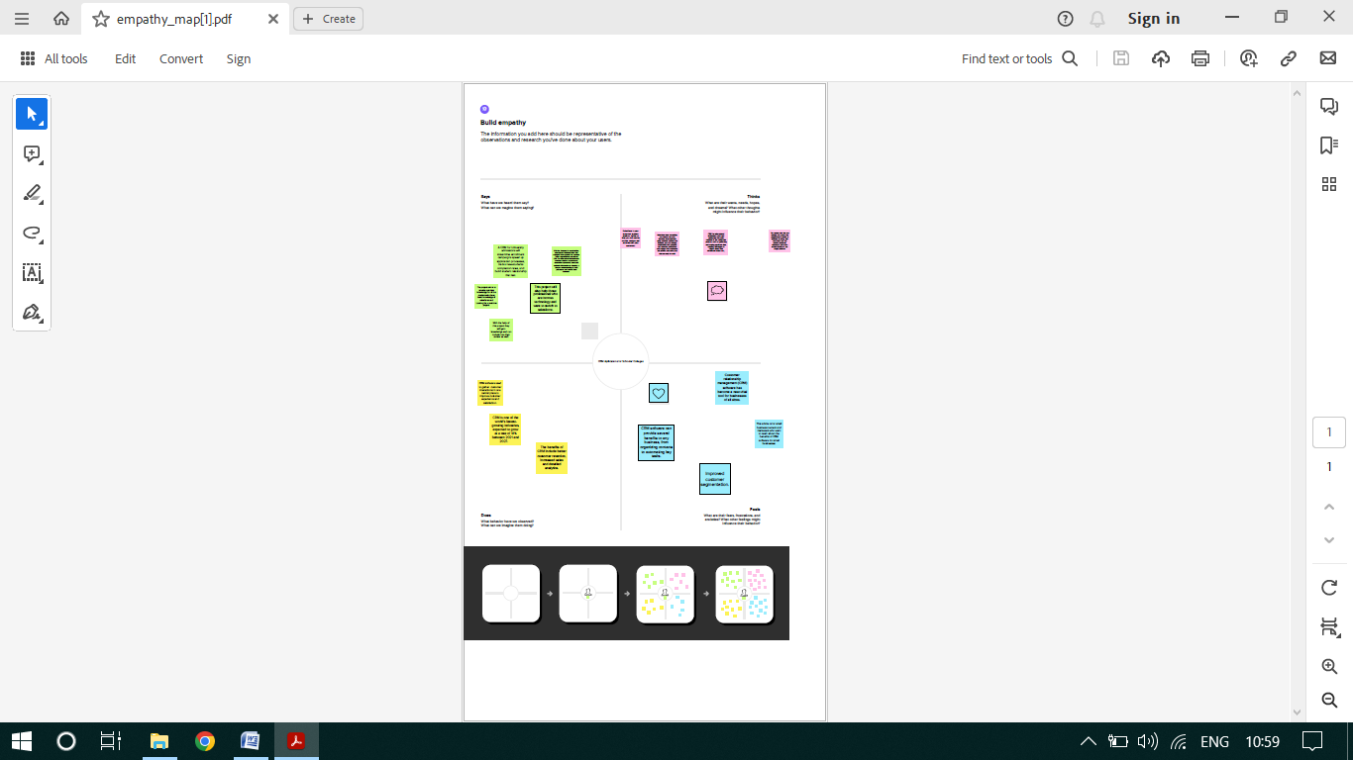

* 1. Ideation 2.2 Ideation & Brainstorming Map

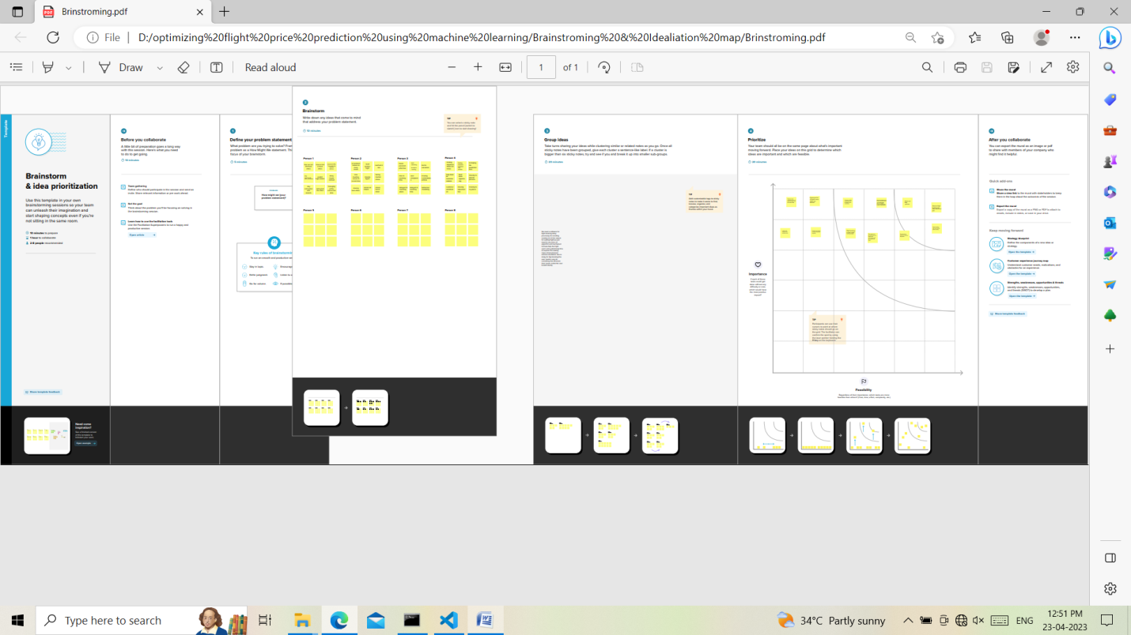

3.Result

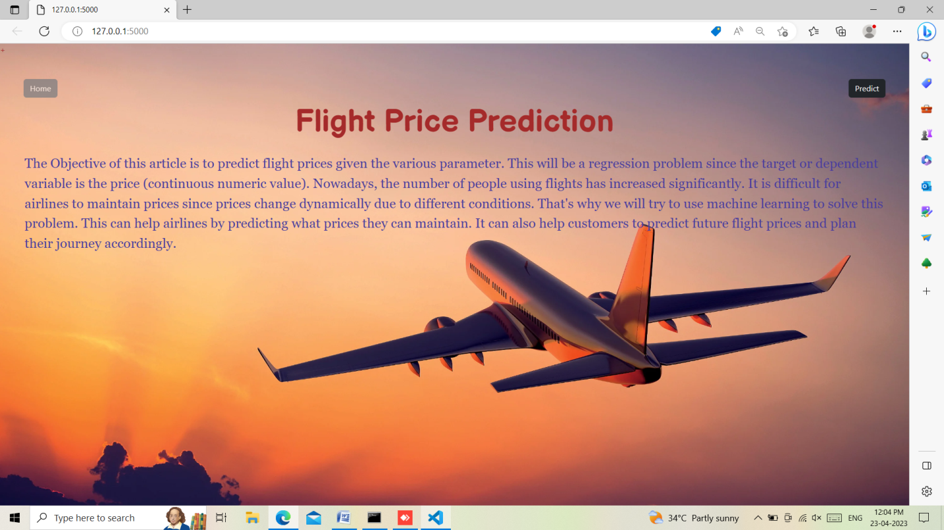

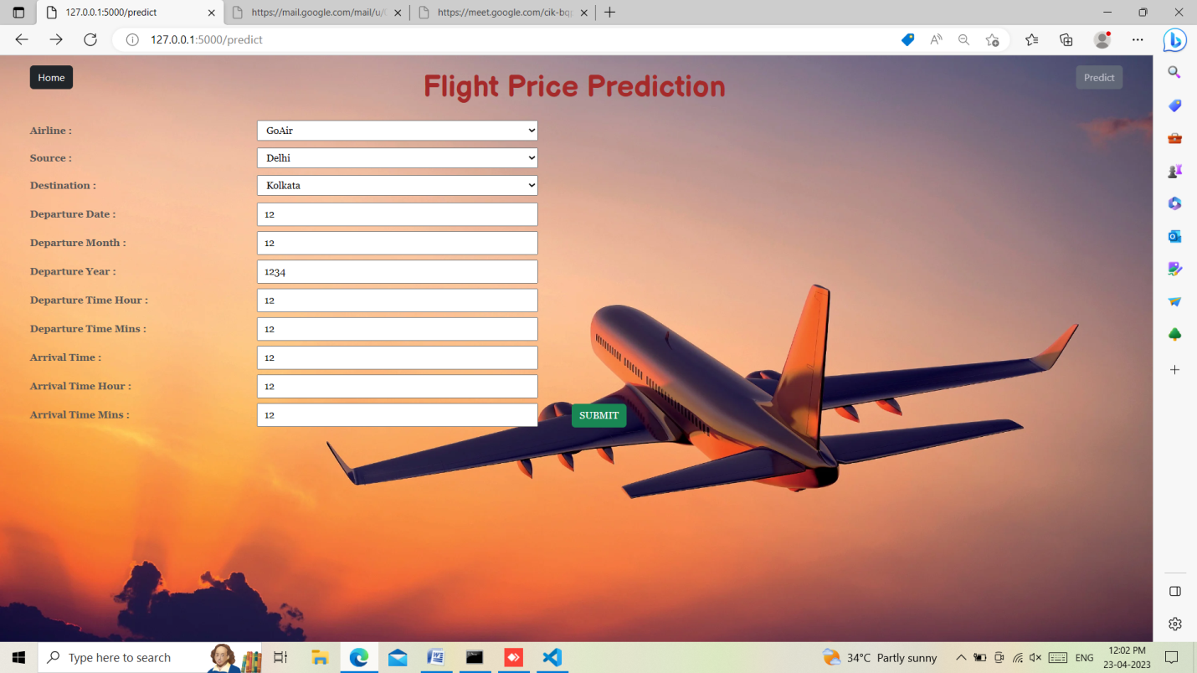

4 Advantages & Disadvantages

Advantages:

* Easy to book tickets.
* Saves time and money.
* Provides every information about flight.
* 24/7 customer support through chat and calls.
* Mobile Availability.
* Send automated tickets to the customer by mail.
* Easy Refund Policies.
* Available for both Domestic and International Airlines.

Disadvandages:

* You need internet access. Reliable internet access is required to check reservations and add bookings that are made over the phone. ...
* You need to be ready for an influx of new customers. ...
* Not all online booking systems are created equal.

5 Application

Flight booking applications **help the airline industry automate the booking process**. Users worldwide can book flights on the go using the simple apps, which include features such as quick flight search, download tickets, check and modify booking details, one-tap check-in, and many more.

6 Conclusion

Flight booking applications **help the airline industry automate the booking process**. Users worldwide can book flights on the go using the simple apps, which include features such as quick flight search, download tickets, check and modify booking details, one-tap check-in, and many more.

7 Future Scope

Flight booking applications **help the airline industry automate the booking process**. Users worldwide can book flights on the go using the simple apps, which include features such as quick flight search, download tickets, check and modify booking details, one-tap check-in, and many mo

8 Appendix

* 1. Source Code

from flask import Flask, render_template, request

import numpy as np

import pickle

import pandas as pd

model = pickle.load(open(r"D:\Flight Price Prediction Using Machine Learning\Flight Price Prediction Using Machine Learning\Training\model1.pkl", 'rb'))

app = Flask(__name__)

@app.route("/")

def home():

    return render_template('home.html')

@app.route('/predict')

def pred():

    return render_template('predict.html')

@app.route('/pred', methods=['POST', 'GET'])

def predict():

    x = [[int(x) for x in request.form.values()]]

    print(x)

    x = np.array(x)

    print(x.shape)

    print(x)

    pred = model.predict(x)

    print(pred[0])

    # name = request.form['airline']

    # return render_template('submit.html', prediction_text = x)

    return render_template('submit.html', prediction_text = pred[0])

if __name__ == '__main__':

    app.run(debug=False)

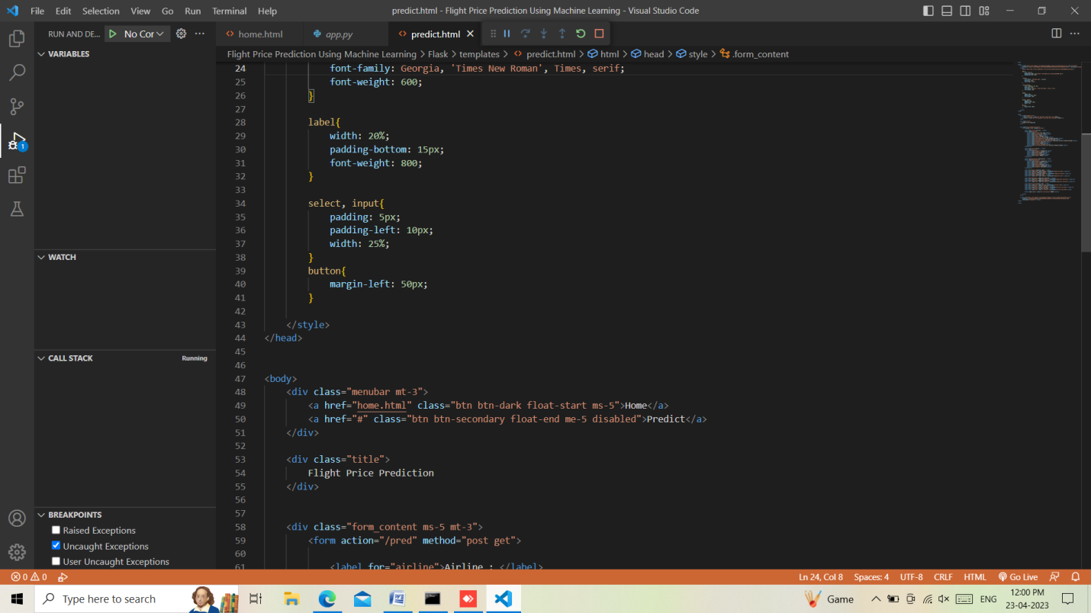

SCREEN SHOTS :



